**Annual Return**

Return of One time investment. Example FD

**CAGR (Compound Annual Growth Rate (CAGR)**

**Formula**-

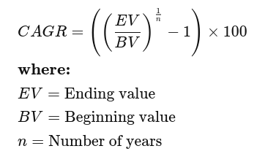

**XIRR (Extended Internal Rate of Return)**

Return of **SIP (Systematic investment plans)**

Used to calculate returns on investments where there are multiple transactions taking place in different times.

**Formula**-

Summation of CAGR of different transitions of SIP

**Absolute return**

Absolute return can be defined as the return, i.e., absolute gain or loss, an investment generates over a specific period of time. The gain or loss is expressed as a percentage of the total investment.

***Absolute Return = ((Current Value - Purchase Value)/Purchase Value)*100***

**MSME (Micro, Small and Medium enterprises)**

***Bond Market and stock market are inversely proportional.***

**GTT (Good Till triggered)**